Coast & Islands Orienteering Week
Coll, 14-18th September 2026

We look forward to welcoming you to Coll for what promises to be an exciting, challenging and enjoyable week of orienteering!

Google Map of the week

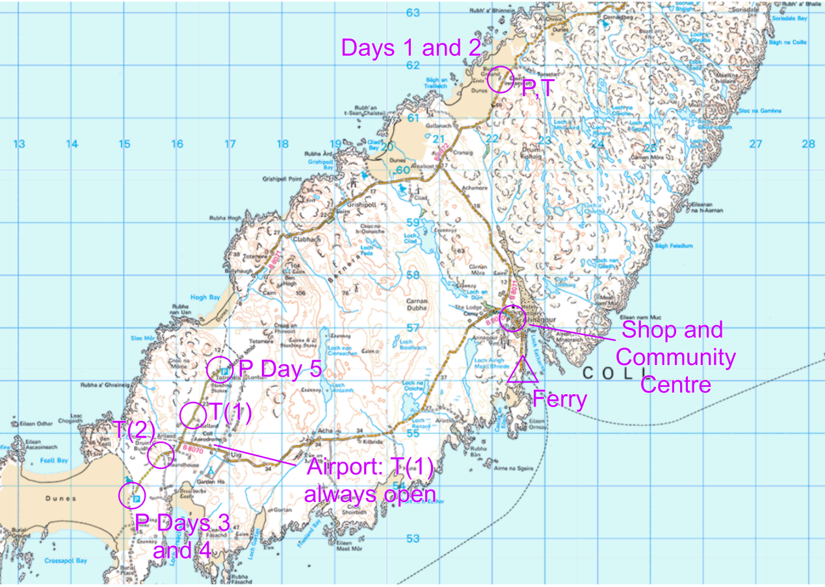

Program

Monday 14th Sept | Day 1 - Middle | Torastan (Beach)
Tuesday 15th Sept | Day 2 - Classic | Torastan (Inland)
Wednesday 16th Sept | Day 3 - Middle | Traigh Feall
Thursday 17th Sept | Day 4 - Classic | Crossapol and Traigh Feall
Friday 18th Sept | Day 5 - Middle | Traigh Hogh

WhatsApp Community: This will include separate groups for e.g. car sharing, along with announcements from the organisers. Important announcements e.g. cancellations will still be emailed. Join Coast & Islands WhatsApp

General island information:

The grocery shop, Coll Stores, is open Mon-Sat 10am-1pm and 4-5pm.
The community centre, An Cridhe, is open 9am-9pm and is a great space with lots on offer. Manned office hours 10am-3pm. Showers (£1 coins) and toilets available 24/7 via the side door.

The roads are all single track. Please drive slowly and cautiously, particularly as there will be many people cycling during the week. Use passing places to let people overtake to avoid queues forming.
Information relevant to all competition days:

- Car sharing: Parking is limited on all days, and particularly days 1 and 2, so please aim for 4 or more people in your vehicle. Make use of the “Lifts/Car Sharing” group on the WhatsApp to coordinate.
- Assembly: As usual at Coast & Islands, the Assembly area (aka Arena) will be very minimal in terms of infrastructure. No food traders or equipment shops.
- First Aid: We will have a first aid kit at Assembly. An emergency contact number for the organiser will be printed on the maps, but in a serious emergency dial 999.
- Results: We will use the SportIdent app for download and so results will be at Events · Masterplan Adventure · SPORTident Center. They will be live if we have internet signal.
- Maps: 1:7500 with 2.5m contours. Power lines and pylons are shown on Orange course maps only. There is not a single tree all week, so to save ink ‘rough open land’ is white rather than pale yellow.
- Punching: SportIdent, touch-free enabled.
- Clothing: Full leg cover is strongly recommended. The sand dunes have some marram grass, and the ‘rocky hills’ areas have some tussocky long grass. You may also find ticks so please check yourselves after each race.
- Organisers: Alasdair Pedley (07463671798), Mairi Eades and Steve Smirthwaite.
- Safety: Please be very careful if you go close to the sea cliffs. They can be large and often have little warning above them. The terrain contains many other crags as well, which can be large.
- You must report to download even if you retire.
- Buddy: Please choose a friend/family member to be your buddy and if they are out much longer than you expect, alert the organisers at download. With a small organising team this is very helpful.
- Starts: Open starts within the window. Queues may form during the middle of the window. We will operate the same procedure as previous years - arrive at the start, report to start official who will give you the next available start time, go warm up/wait. This saves you standing in a queue getting cold and stiff.
- Course closing times: We will be strict about these and will begin collecting controls at this time. If you think you may be out for a long time please start early in the window. This applies particularly on Day 1 as the event is in the afternoon and has an earlier course closing time.

Competition Information

Day 1 - Traigh Torastan (Torastan Beach)

Assembly and Parking: At the cemetery at Torastan. Google Maps.

Start: Adjacent to Assembly.

Finish: Adjacent to Assembly.

Toilets: Adjacent to Assembly.

Start times: 13:00 - 16:00. Courses close at 17:30. Please start early if you think you may be out for over an hour.

Courses:
Course | Distance (km) | Climb (m) | Controls
Long | 5.0 | 180 | 20
Medium | 4.0 | 140 | 17
Short | 3.1 | 90 | 11
Orange | 2.1 | 50 | 10
*Long will have a double-sided map.

Map: Martin Bagness, June 2026.
Planner: Martin Bagness
Terrain: Sand dunes and rocky hills. The sand dunes offer generally fast running and complex contours. The rocky hills have myriad crags and rock detail with sometimes marshier ground between.

Day 2 - Torastan

Assembly and Parking: At the cemetery at Torastan. Google Maps.

Start: 500m with 30m climb from Assembly.

Finish: Adjacent to Assembly.

Toilets: Adjacent to Assembly.

Start times: 10:00 - 13:00. Courses close at 15:00.

Courses:
Course | Distance (km) | Climb (m) | Controls
Long | 6.8 | 235 | 22
Medium | 4.9 | 170 | 18
Short | 3.2 | 110 | 12
Orange | 2.0 | 50 | 7

Map: Martin Bagness, June 2026.
Planner: Martin Bagness

Terrain: Rocky hills, with plenty of contour detail and generally marshier ground between the hills. The long course visits a tougher area with bigger crags.

Day 3 - Traigh Feall and Ben Feall

Assembly and Parking: At the “Crossapol” Car Park at the end of the road. Google Maps.

Start: 1km almost all flat from Assembly.

Finish: 200m from Assembly.

Toilets: 900m from Assembly. You can drop people off on your way to parking at the event. Do not attempt to park at the toilet.

Start times: 10:00 - 13:00. Courses close at 15:00.

Courses:
Course | Distance (km) | Climb (m) | Controls
Long | 5.7 | 220 | 22
Medium | 4.5 | 180 | 15
Short | 3.4 | 100 | 13
Orange | 1.9 | 35 | 8

Map: Alasdair Pedley, April 2026 and Steve Smirthwaite, October 2025.
Green undergrowth stripes are generally used for areas of taller marram grass on the sand dunes, but also indicate bracken on the rocky hill.
Planner: Alasdair Pedley
Terrain: Predominantly grassy sand dunes, with an interesting mix of flatter, faster sections and bigger, steeper dunes. All courses visit a ‘rocky hill’ area, though for Short and Orange this is only a small fraction of the course.

Day 4 - Crossapol and Traigh Feall

Assembly and Parking: At the “Crossapol” Car Park at the end of the road. Google Maps.

Start: 450m with no climb from Assembly.

Finish: 200m from Assembly.

Toilets: 900m from Assembly. You can drop people off on your way to parking at the event. Do not attempt to park at the toilet.

Start times: 10:00 - 13:00. Courses close at 15:00.

Courses:
Course | Distance (km) | Climb (m) | Controls
Long | 9.8 | 280 | 28
Medium | 7.2 | 210 | 18
Short | 5.5 | 145 | 16
Orange | 2.5 | 55 | 7

Some fences have purple overprint on the map. These are forbidden to cross. Other fences can be crossed anywhere (but the natural route choices should lead you to cross at gates).

Map: Alasdair Pedley, April 2026. Green undergrowth stripes are generally used for areas of taller marram grass. The pale yellow colour (usually ‘rough open’ on normal maps but of course that is white this week) has been used for sand (on the beaches) and also sandier ground within the dunes, usually offering slower than average running.
Planner: Alasdair Pedley

Terrain: Predominantly grassy sand dunes, with an interesting mix of flatter, faster sections and bigger, steeper dunes. Long and Medium visit a small area of rocky hills at the far end of the area.

Day 5 - Traigh Hogh

Assembly and Parking: At the Traigh Hogh Car Park at the end of the road (the other end to Days 3 and 4). Google Maps.

Start: Adjacent to Assembly.

Finish: Adjacent to Assembly.

Toilets: 800m from Assembly. Only one toilet. You can drop people off on your way to parking at the event. Do not attempt to park at the toilet.

Start times: 08:00 - 11:00. Courses close at 13:00.

Courses:
Course | Distance (km) | Climb (m) | Controls
Long | 6.2 | 265 | 17
Medium | 4.6 | 195 | 15
Short | 3.2 | 120 | 12
Orange | 2.1 | 45 | 9

Map: Martin Bagness, October 2025. Some dot knolls have been reduced in size for clarity.
Planner: Martin Bagness and Alasdair Pedley

Terrain: Predominantly grassy sand dunes, with an interesting mix of flatter, faster sections and bigger, steeper dunes. Long and Medium visit a small area of rocky hills at the far end of the area.
Other information

Prizes: Overall prizes for the first man and woman on each course.
Merchandise: TBC.

